Separation and Identification of Hydrocarbons and Determination of Ethanol Concentration in Alcoholic Beverage With Gas Chromatography

Max Shi

*Department of Chemistry, Stevens Institute of Technology, Castle Point on Hudson, Hoboken, NJ 07030.*

*Performed November 9, 2020, submitted November 17, 2020.*

**Abstract**: In the first part of this two-part experiment, Gas Chromatography (GC) was used to create a chromatogram of n-tetradecane. Then, GC was used again to separate normal hydrocarbons from n-heptane to n-eicosane and recover a chromatogram of the separated mixture. Then, by comparing the chromatogram of the known compound with the mixture, an unknown compound was put through GC and using that chromatogram and comparing with the mixture, the unknown hydrocarbon was concluded to be n-dodecane. In each chromatogram, 1 µL was injected into the system.

In the second part of the experiment, GC was used to determine the concentration of ethanol in an alcoholic beverage. To begin, five calibration solutions of 30, 40, 50, 60, and 70% v/v ethanol in water were produced. Then, 1.00 mL was transferred into a GC vial, and an internal standard of 0.25 mL 1-propanol was added. Then, after injecting each of the calibration solutions into the GC machine and obtaining chromatograms, the same process was applied to the alcoholic beverage with the internal standard. After calculating the ratio of analyte to internal standard with regards to peak area and concentration, a relative response factor (RRF) was calculated, and that number was used to calculate a concentration of 40.58% v/v ethanol in the original alcoholic beverage.

**Introduction**

Chromatography is a technique where samples are analyzed by separation of their components through a column and analyzing when and how intense the response is when each component arrives at the end of the column. This is done with interactions between two phases, known as the mobile phase and stationary phase.

In gas chromatography, the mobile phase is a carrier gas that carries the aspirated sample through the GC column. The stationary phase is dependent on the type of column being used in the GC machine. Porous layer open tubular (PLOT) columns use a porous layer of solid adsorbent to interact with the mobile phase. Wall-coated open tubular (WCOT) columns use a directly coated column wall with liquid polymer as the stationary phase. Finally, support-coated open tubular (SCOT) columns use a combination of the two aforementioned column designs, where solid adsorbent material lines the column wall, coated with the liquid phase.

As the sample is aspirated by the injector and carried through the column, different components of the analyte will interact with the stationary phase and slow down, based on the component’s volatility. Therefore, the different components will be separated and arrive at the end of the column at different times. At the end of the column is the detector, which in this experiment, is a flame ionization detector (FID). As the compounds pass through the detector, they are passed through the flame, and the subsequent combustion reaction releases electrons, which are picked up by the detector. Another type of detector is the thermal conductivity detector (TCD), which takes advantage of the change in thermal conductivity observed when an analyte passes through the detector. A change in thermal conductivity affects the resistance of a wire in the detector, and the voltage change caused as a result is recorded by the computer. In both cases, the intensity can be measured, as well as the time it takes to reach the end of the column, also known as the retention time. These two variables are plotted on a graph, called the chromatogram. The setup, in greater detail, is depicted in Figure 1.

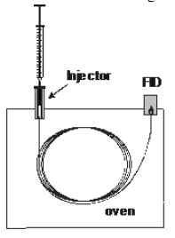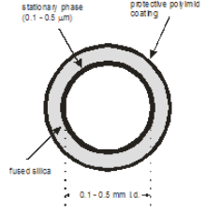

Figure 1: Gas Chromatograph (left) and Inside of the Column (right)

In the first part of this experiment, GC can be used to identify an unknown hydrocarbon from a mixture of hydrocarbons. Because hydrocarbons with different chain lengths have different levels of volatility, these compounds in a mixture separate through a GC column. In this sense, chain length is directly proportional to retention time. To identify the unknown, the retention time of the unknown, measured through its chromatogram, can be matched up with a corresponding retention time in the hydrocarbon mixture.

For the second part of this experiment, determining the concentration of ethanol in an alcoholic beverage, the process is more complicated. The use of an internal standard in this portion allows for a relationship to be set up between the concentration and peak area of an analyte and the internal standard, as detailed in Equation 1 and Equation 2.

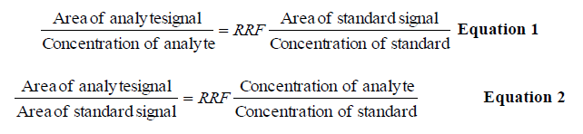

In equation 1, the relationship between area of signal compared to the concentration is known as the relative response factor, and by moving some of the terms around, the ratio of analyte signal area to standard signal area is directly proportional to the ratio of concentration of analyte to the concentration of standard. By keeping the concentration of the standard constant in all steps, and preparing calibration solutions of different concentrations of analyte, a calibration plot can be created to determine a value for RRF. Thus, after obtaining this value, the area of the peak corresponding to ethanol in the chromatogram of the unknown can be used to recover the concentration of ethanol in the alcoholic beverage.

**Experimental**

In this experiment, all chemical compounds and alcoholic beverage were provided by the TAs. The machine used for the first part of the experiment was the Agilent 6890 Gas Chromatograph with flame ionization detector, and the machine used for the second part of the experiment was the Hewlett-Packard 5890 Series II Gas Chromatograph with flame ionization detector.

To begin the experiment 1 µL of n-tetradecane (CAS#: 629-59-4) was injected into the system while running a temperature gradient program. After generating the chromatogram, the retention time and peak areas were calculated, as seen in Figure 2.

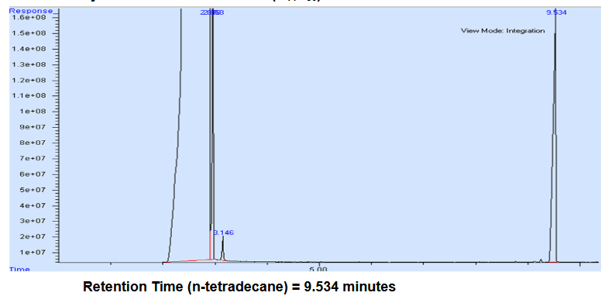

Figure :Chromatogram of n-tetradecane

The peak of n-tetradecane can be seen at 9.534 minutes, while all peaks before 3.25 minutes can be ignored, as those peaks are due to the solvent getting detected in the flame aspirator.

Next, 1 µL of the hydrocarbon mixture was loaded into the GC machine, and a chromatogram was generated. As with the previous part, the peak areas and retention times were calculated and recorded, as seen in Figures 3 and 4.

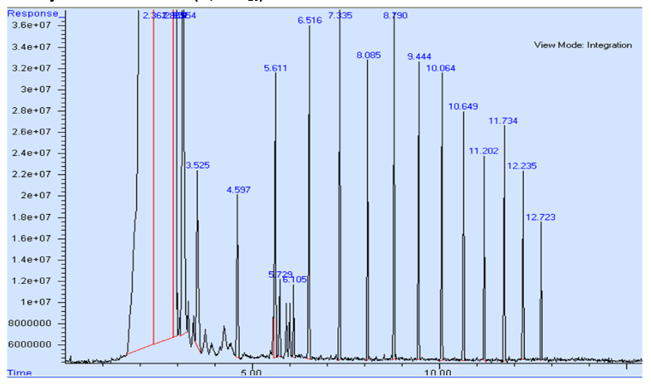

Figure : Chromatogram of Hydrocarbon Mixture

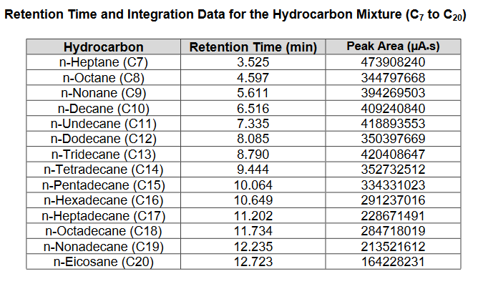

Figure : Table of Retention Times and Peak Areas in Hydrocarbon Mixture

Again, all peaks before 3.25 minutes are ignored due to solvent, and the peaks between 5.611 and 6.516 are due to impurities. Because chain length is inversely proportional to volatility, and volatility is inversely proportional to retention time, chain length is directly proportional to retention time. Thus, each hydrocarbon can be associated in ascending order with the peaks at increasing retention times. Note that n-tetradecane in this step has a retention time of 9.444 minutes, very similar to the retention time measured with n-tetradecane alone which was 9.534 minutes.

Finally, the 1 µL of the unknown hydrocarbon was injected into the GC machine, and the chromatogram is shown in Figure 5.

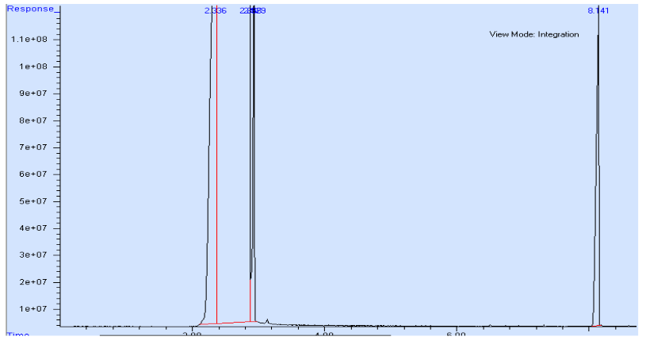

Figure : Chromatogram of Unknown Hydrocarbon

The retention time of this hydrocarbon was 8.141 minutes, which matches up closest with n-dodecane, with a retention time of 8.085 minutes in the hydrocarbon mixture. Thus, by using GC, the unknown was concluded to be n-dodecane.

For the second part of this experiment, five 50 mL calibration solutions of ethanol (CAS#: 64-17-5) were created of 30, 40, 50, 60, and 70% v/v concentration by diluting 15, 20, 25, 30, and 35 mL of ethanol to 50 mL with deionized water in five 50-mL volumetric flasks, respectively. Then, 1.00 mL of each calibration solution was transferred to a 3-mL GC vial, to which 0.25 mL 1-propanol was added. This resulted in the concentration of ethanol dropping to 24, 32, 40, 48, and 56% v/v, respectively, with the concentration of 1-propanol being 20% v/v in each vial. A GC vial representing the unknown was also prepared with 1.00 mL of the alcoholic beverage and 0.25 mL 1-propanol. Then, each vial was put into the chromatogram and the measured chromatograms are depicted in Figure 6-11.

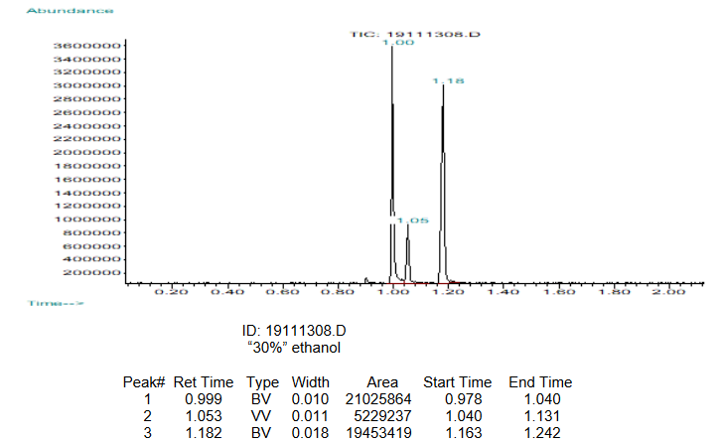

Figure : Chromatogram of 30% Ethanol Solution

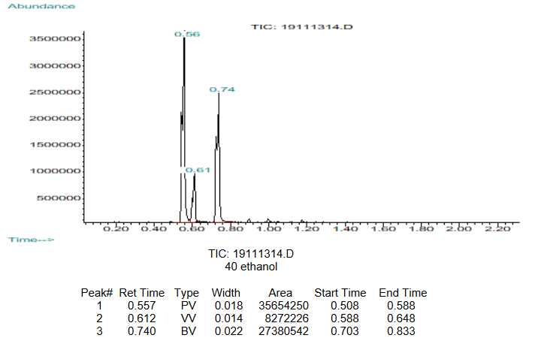

Figure : Chromatogram of 40% Ethanol Solution

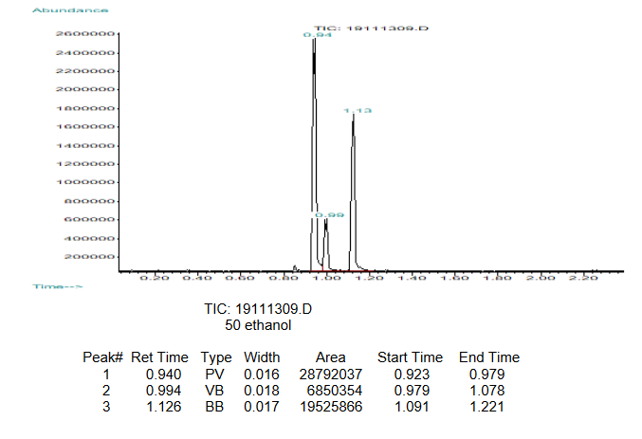

Figure : Chromatogram of 50% Ethanol Solution

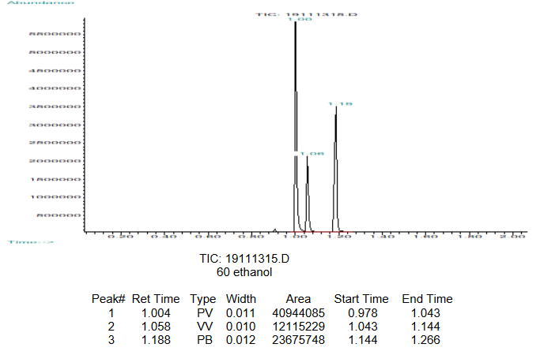

Figure : Chromatogram of 60% Ethanol Solution

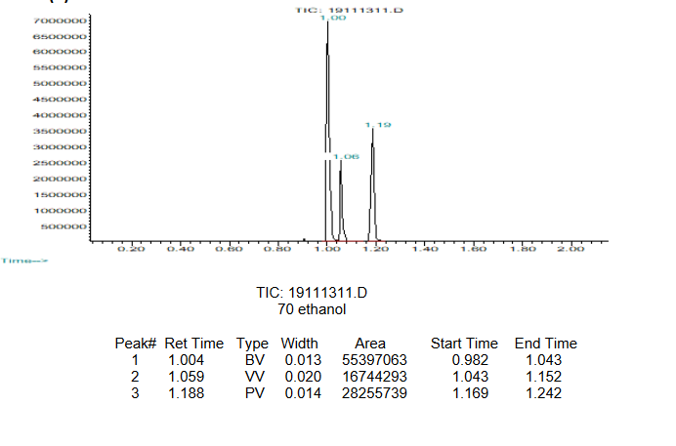

Figure : Chromatogram of 70% Ethanol Solution

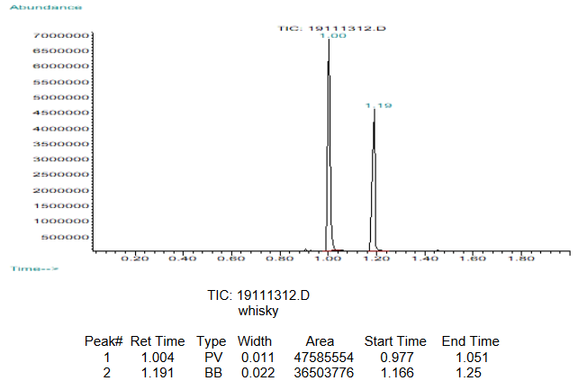

Figure : Chromatogram of Whiskey

In each of these chromatograms, the middle peak in between two large peaks is an impurity, which is ignored. Because ethanol is more volatile than 1-propanol, the ethanol peak is the peak with the lower retention time, while the 1-propanol peak is the peak with the higher retention time. Each peak area has been integrated, and the following table, in Figure 12, has been filled with the corresponding data to do calculate a calibration curve.

|  |  |  |  |  |  |
| --- | --- | --- | --- | --- | --- |
| Ethanol  Concentration (% v/v) | Peak  area of ethanol signal (AU) | 1-propanol  concentration (% v/v) | Peak area of 1-propanol signal (AU) | Area (ethanol) ÷ Area (1-propanol) | Concentration (ethanol) ÷ Concentration (1-propanol) |
| 24 | 21025864 | 20 | 19453419 | 1.080831292 | 1.2 |
| 32 | 35654250 | 20 | 27380542 | 1.302174734 | 1.6 |
| 40 | 28792037 | 20 | 19525866 | 1.474558772 | 2 |
| 48 | 40944085 | 20 | 23675748 | 1.72936817 | 2.4 |
| 56 | 55397063 | 20 | 28255739 | 1.960559694 | 2.8 |
| Unknown | 47585554 | 20 | 36503776 | 1.30357895 | Unknown |

Figure : Calculation Table for GC Calibration Plot

Then, using the data points of the calibration sample and the relationship defined in equation 2, the following calibration plot was calculated, as seen in Figure 13.

Figure : Calibration Plot of GC Vial Solutions

After subtracting the y-intercept of the regression equation from all peak area ratios, the final calibration plot was achieved, as seen in Figure 14.

Figure : Final Calibration Plot of GC Vials

Using the slope of the regression equation, the RRF was calculated to be 0.5467. After subtracting the y-intercept from the peak area ratio of the unknown, the value is 0.8874. Plugging this into equation 2, with the concentration of 1-propanol at 20% v/v, the concentration of the ethanol in the GC vial was calculated to be 32.46%. Because this was diluted from 1.00 mL to 1.25 mL by the 1-propanol, multiplying this value by 1.25 recovers the concentration of ethanol in the whiskey, which is 40.58%.

**References**

1. Attygalle, A. Instrumental Analysis I Lecture and Laboratory Manual <https://sit.instructure.com/courses/38802/files/6982711?module_item_id=1042514> (accessed Nov 17, 2020).
2. Harris, D. C. *Quantitative Chemical Analysis*, 8th ed.; W.H. Freeman and Co: New York, 2010. Chapter 23.
3. Rahman, M. M.; El‐Aty, A. M. A.; Choi, J.-H.; Shin, H.-C.; Shin, S. C.; Shim, J.-H. Basic Overview on Gas Chromatography Columns. In *Analytical Separation Science*; American Cancer Society, 2015; pp 823–834. <https://doi.org/10.1002/9783527678129.assep024>.